**Guided Capstone Project Report**

**Big Mountain Resort Price Study**

Daren Scot Wilson

Sept 11, 2025

**SYNOPSIS:** We find there's room to increase lift ticket prices from $81 to around $90 – $95, based on comparisons to other ski resorts and their features. Changes to Big Mountain’s physical features, such as number of runs, could allow smaller additional increases.

**The Question**

The question before us is: Does Big Mountain charge a price for lifts in line with what other resorts charge? Given the current price of $81, is there room to increase this and thus revenue?

**The Data**

We have been given data on 330 resorts with 27 data items for each, including name, state, number of runs, length of longest run, numbers of various types of lifts, snow-making capability, and so on, and their current (at the time of data collection) prices.

About 16% of the resorts listed did not have ticket prices, and so were dropped. Certain features were dropped, such as the number of Fast Eights, due to very few resorts having any, thus not enough data on that feature in our dataset to fit any models to.

Each resort has a weekend price and a weekday price. For many resorts these were the same, and for most of the others, weekend prices were $10 or $20 more than for weekdays, and the rest differed by varying amounts. The more expensive ski resorts were more likely to have one price for all days.

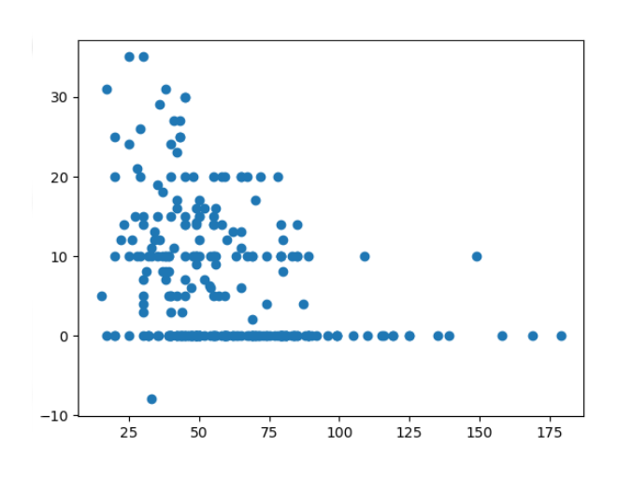

Several resorts had weekend prices only, but very few had weekday only prices, This difference understood, we chose to model only the weekend prices. Once the weekday prices feature was dropped, and a few more resorts were removed for having unreliable or missing data, our dataset had 277 resorts and 25 features.

The resorts dataset was augmented with data on state areas and populations, obtained from wikipedia, so that we could calculate the number of resorts per 100,000 population and resorts per 100,000 square miles.

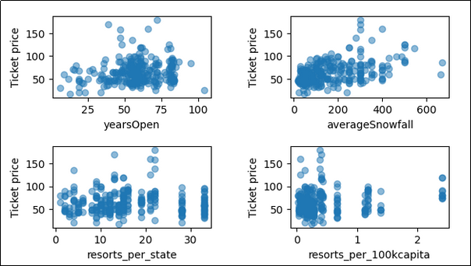

Looking at various features we found Big Mountain sits at the higher end for some, specifically or skiable terrain area, snow-making area, longest run length, total number of runs, total number of chairs, and number of fast quads. Two example plots are shown here.

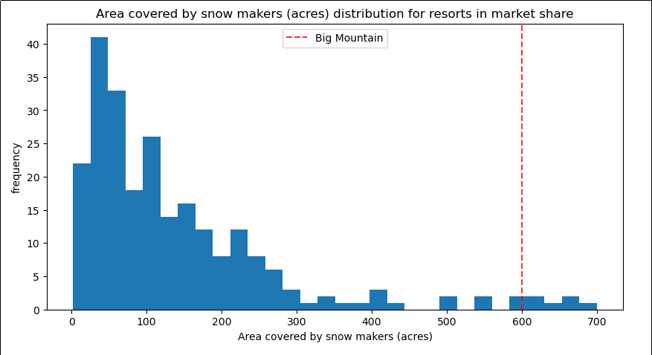

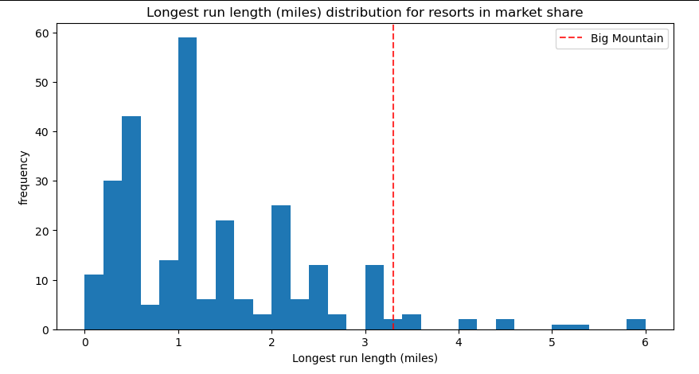

If anything, these suggest that Big Mountain has assets that put it among the bigger and better ski resorts, and could easily price accordingly.

**Models**

The very simplest mathematical pricing model is to just set the price to a constant, the average of all resorts nationwide or statewide or some other group. While not useful for making recommendations, it does provide a standard reference for comparing the quality of other models.

The first potentially useful model we explored as a linear fit to all numerical resort features. The technique of Principal Component Analysis (PCA) revealed that only a few combinations of features accounted for most the price variations. This model seemed to do fairly well but wasn't impressive.

The next model we tried was a Random Forest, which combines several Decision Trees. A typical Decision Tree starts with a question for example "is the number of ski runs greater than twelve?" If the answer is yes, the next question may be "is it greater than fifteen?" or could be about some other feature. A "no" would lead to other questions. Eventually some result like "an adult weekend ticked is $75". No one Decision Tree performs well, but a Random Forest can combine a few, up to hundreds, with a way to determining which is "best" from its training on known data. The Random Forest can then be used to make predictions, and also can report on which inputs were most important for reaching that prediction.

For our study, our RF pricing model reports that the top five most important features are:

fastQuads

Runs

Snow making acres

vertical drop

skiable terrain acres

**Main Conclusion**

When our RF model, trained on all resorts except Big Mountain, is given the features of Big Mountain, it predicts a price of $95.87 which we could round up to a neat $96.

From the linear fit and the RF models, and plots of prices versus features, we see enough individual random variations that we don't expect any pricing model to be more accurate than about a few dollars. The measure of how well a model fits the data is given by a Mean Absolute Error (MAE) of about $10. Thus it seems fair to drop the 87 cents and call the optimum price either $95 or $96, and a dollar or two more or less would be fine. Reducing the MAE would make a great goal for further work.

**Alternative Scenarios**

What if Big Mountain made changes to its facilities? For example, adding new runs, or close unpopular runs. We considered three scenarios.

Scenario 1: Closing some of the least used runs. We varied the number of runs to close from zero to ten. According to the pricing model, closing one to five runs lowers the model's predicted price by less than one dollar, or equivalently, lowers revenue by roughly one million dollars or less, based on 350,000 visitors expected per year and the average visitor skiing for five days. Closing six or more runs drops revenue by over two million.

This strategy could increase profits if runs could be identified that are both unpopular and have higher than typical operating costs. According to the Problem Statement, the operating costs for one run (the latest new one, not necessarily a typical one) is about $1.5M. If we take this as typical of any run, and from the plot we see that revenue goes down roughly 3M for ten runs closed, or about 0.3M per run. That loss in revenue is much less than the 1.5M operating cost, so it makes sense from a financial point of view.

Scenario 2: Adding one more run, increasing vertical drop by 150 feet, and adding one more chair lift. Changing Big Mountain's features in this lead to a predicted optimum price of $1.99 more than our main conclusion, or about $3.5M of extra annual revenue.

Scenario 3: Same as Scenario 2, but also adding two acres of snow-making capability. This made no difference. If we add 20 acres, still no change, but adding 200 acres allowed an increase of $3.79, which given the expected number of visitors previously used, about $10.1M in extra annual revenue.

A fourth scenario explored if very small changes would affect the price. Random Forests sometimes have a habit of not changing their outputs when small changes of inputs are made.

**Recommendations**

* Increase the lift ticket price from $81 into the range $90 -- $96

* Close from one to up to six runs that are unpopular and not of interest to expert or specialized skiers.

* Add more snow-making area, on the order of 100 to a few hundred acres, if the cost can be recovered by the expected additional revenue in a reasonable time.

Caution

Note that our suggested price is only the result of a mathematical model. We do not take into account the impression a price increase would make on potential customers, the effects of special discounts for categories of customers e.g. seniors, kids, and holidays, or how a price increase would be rolled out. The idea of closing some less popular ski runs does not take into account unique features of those runs, such as difficulty. A tricky run requiring black diamond skills will never be used by regular skiers, and so may be classified as 'unpopular' but you wouldn't want to close it thereby losing high end guests.

We are also assuming that the pricing of other ski resorts are already optimum, wisely chosen, and that most of them are not performing pricing data science studies like ours.

**Future Possible Work**

* A better pricing model could be developed with additional information, such as:

** Stats on tourists versus local residents.

** Numbers of various types of runs, such as blue and black diamond.

** Obtaining pricing information for the 16% of all resorts that we had to drop for not having that data.

** Facilities and availability of instructors for total beginners.

* Since the optimum ticket price varies with resort features, such as the total number of runs, decision makers may want to explore more scenarios than we covered in this study. For example, increasing the total vertical drop of some runs, without removing or adding any runs. It is possible to package our pricing model for back end use in an in-house web app, providing controls to vary features while seeing how the optimum price changes in real time.